**Creating an Application Gateway**

**What is an Application Gateway?**

* An Application Gateway is a web traffic load balancer that works on layer 7 of the OSI model
* It can make routing decisions based on additional attributes of an HTTP request, for example URI path.
* It supports SSL/TLS termination at the gateway, after which traffic typically flows unencrypted to the backend servers
* It is a fully managed Application Delivery Controller (ADC) service for securing, optimizing, and load balancing web traffic in Azure.

# ****Architecture Diagr**am**

# 

**Task Details**

1. Sign in to Azure Portal
2. Create a Virtual Network
3. Create Virtual Machines
4. Install IIS in both Virtual Machines
5. Create an Application Gateway
6. Test the Application Gateway
7. Validation test
8. Delete the resources

# ****Lab Steps****

## ****Task 1: Sign in to Azure Portal****

## ****Task 2: Create a Virtual Network****

1. Click on **Create a resource** button

# https://labresources.whizlabs.com/df188e7663ade4ce6b66b8c29f276ae4/1.png

1. In the search box, enter **Virtual Network**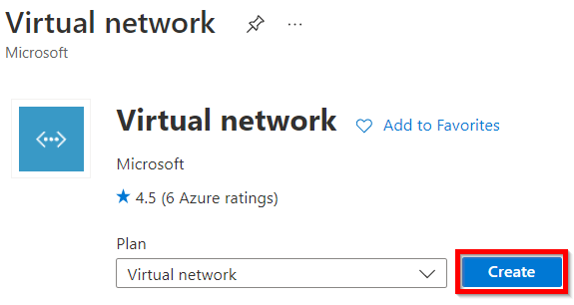
2. Select **Create** and enter the following values in the **Basics** tab.

* Resource group : Select **rg_eastus_XXXXX**
* Instance details:  
  + Virtual Network Name: Enter **whizNet1**
  + Region: Select **East US**

# https://labresources.whizlabs.com/df188e7663ade4ce6b66b8c29f276ae4/3.png

1. Click on the **Next: IP Addresses** button and enter or select the following details:

* IPv4 address space: Enter **10.1.0.0/16**

# https://labresources.whizlabs.com/df188e7663ade4ce6b66b8c29f276ae4/4.png

1. Check the box on left of **default** subnet, and click on **Remove Subnet** button.

# https://labresources.whizlabs.com/df188e7663ade4ce6b66b8c29f276ae4/5.png

1. Now, Click on the **+Add Subnet** button.

# https://labresources.whizlabs.com/df188e7663ade4ce6b66b8c29f276ae4/6.png

1. On the **Add Subnet** page, enter or select the following details and click on **add**.

* Subnet Name: Enter **myBackendPool**
* Subnet Address range: Enter **10.1.0.0/24**
* NAT gateway: Leave the defaults
* Service gateway: Leave the defaults

# https://labresources.whizlabs.com/df188e7663ade4ce6b66b8c29f276ae4/7.png

1. Click on **+Add Subnet** button and enter or select the following details and click on **add.**

* Subnet Name: Enter **myApplicationGatewaySubnet**
* Subnet Address range: Enter **10.1.1.0/24**
* NAT gateway: Leave the defaults
* Service gateway: Leave the defaults

# https://labresources.whizlabs.com/df188e7663ade4ce6b66b8c29f276ae4/7a.png

1. Select **Review + Create** and then select **Create.**

# https://labresources.whizlabs.com/df188e7663ade4ce6b66b8c29f276ae4/8.png

## ****Task 3: Create Virtual Machines****

1. In the search box at the top of Azure Portal, search for **Virtual Machines** and select it from the list.

# https://labresources.whizlabs.com/df188e7663ade4ce6b66b8c29f276ae4/9.png

1. Click on **+Create** button and select **Azure Virtual Machine.**

# https://labresources.whizlabs.com/df188e7663ade4ce6b66b8c29f276ae4/10.png

1. On the **Basics** tab, enter or select the following details:

* Resource group : Select **rg_eastus_XXXXX**
* Instance details :
* Virtual Machine Name : Enter **myWhizlabsVM1**
* Region : Select **East US**
* Availability options: Select **No infrastructure redundancy required**
* Image : Select **Windows Server 2019 Datacenter - Gen1**
* Azure Spot instance : Leave the default of unchecked.
* Size : Select **Standard_B2s**
* Administrator Account :
* Username : Enter **vm1**
* Password : Enter a password
* Confirm password : Re-enter password
* Inbound Port rules :
* Public inbound ports : Select **Allow selected ports**
* Select inbound ports : Select **HTTP (80)**, **RDP (3389)**

# https://labresources.whizlabs.com/df188e7663ade4ce6b66b8c29f276ae4/application_gateway_details_1_16_19.gif

1. Click on the **Next: Disks** button and select the following:

* OS disk type: Select **Standard SSD**

# https://labresources.whizlabs.com/df188e7663ade4ce6b66b8c29f276ae4/13.png

1. Click on the **Next: Networking** button and enter or select following details.

* Network Interface:
  + Virtual Network: Select **whizNet1**
  + Subnet: Select **myBackenedPool**

# https://labresources.whizlabs.com/df188e7663ade4ce6b66b8c29f276ae4/14.png

1. Click on the **Next: Monitoring**button and enter or select following details.

* Boot diagnostics: Select **Disable**

# https://labresources.whizlabs.com/df188e7663ade4ce6b66b8c29f276ae4/14a.png

1. Click on the **Review + Create** button and then select **Create.**

# https://labresources.whizlabs.com/df188e7663ade4ce6b66b8c29f276ae4/15.png

1. Repeat steps 1 - 7 to deploy another VM and enter or select the following details.

* Basics tab:
  + Resource group : Select **rg_eastus_XXXXX**
  + Instance details :
    - Virtual Machine Name : Enter **myWhizlabsVM2**
    - Region : Select **East US**
    - Availability options: Select **No infrastructure redundancy required**
    - Image : Select **Windows Server 2019 Datacenter - Gen1**
    - Azure Spot instance : Leave the default of unchecked.
    - Size : Select **Standard_B2s**
* Administrator Account :
  + Username : Enter **vm2**
  + Password : Enter a password
  + Confirm password : Re-enter password
* Inbound Port rules :
  + Public inbound ports : Select **Allow selected ports**
  + Select inbound ports : Select **HTTP (80)**, **RDP (3389)**
* Disks tab:
  + OS disk type: Select **Standard SSD**
* Networking tab:  
  + Network Interface:  
    - Virtual Network: Select **whizNet1**
    - Subnet: Select **myBackenedPool**
* Monitoring tab:  
  + Boot diagnostics: Select **Disable**

# https://labresources.whizlabs.com/df188e7663ade4ce6b66b8c29f276ae4/15_18_32.png

## ****Task 4: Install IIS in both Virtual Machines****

1. In the search box at the top of Azure Portal, search for **Virtual Machines** and select **myWhizlabsVM1** from the list and click on **Connect**.

# https://labresources.whizlabs.com/df188e7663ade4ce6b66b8c29f276ae4/16.png

1. Select **RDP** and click on **Download RDP File** button.

# https://labresources.whizlabs.com/df188e7663ade4ce6b66b8c29f276ae4/17.png

1. Open the download **RDP** file and select **Connect** on the displayed prompt.

# https://labresources.whizlabs.com/df188e7663ade4ce6b66b8c29f276ae4/18.png

1. On the **Windows Security** prompt, click on **more choices.**

# https://labresources.whizlabs.com/df188e7663ade4ce6b66b8c29f276ae4/19.png

1. Click on **Use a different account** and enter the username and password you specified while creating the Virtual Machine and select **OK**.

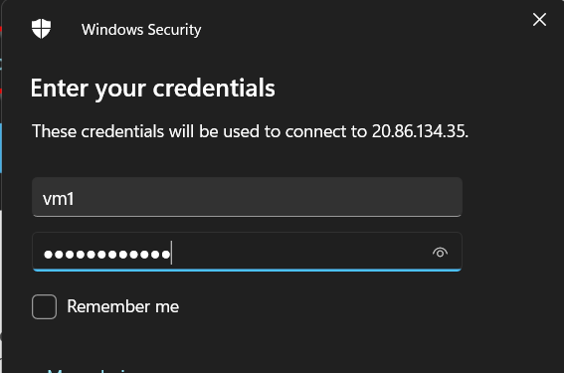

1. You may receive a certificate warning during the sign-in process. Select **Yes** to continue.

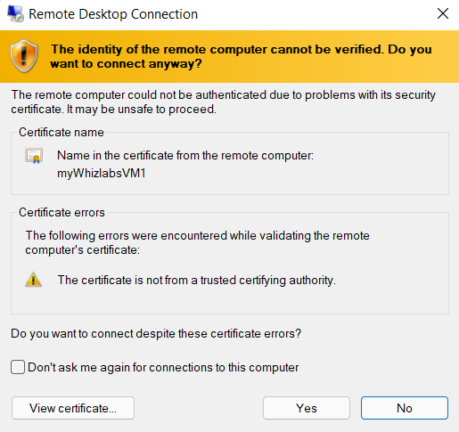

1. In the **Virtual Machine,** open the Service Manager and Click on **Add roles and features**.

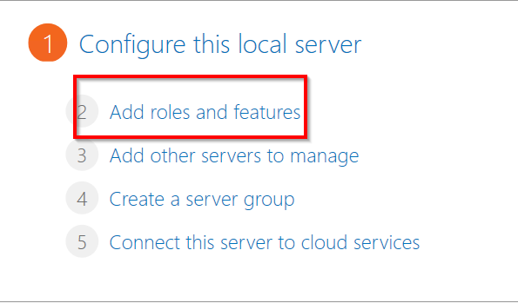

1. Click on **Next** until you get an option to select **Web Server (IIS).** Then again click on **Next** until you get an option to **install**.

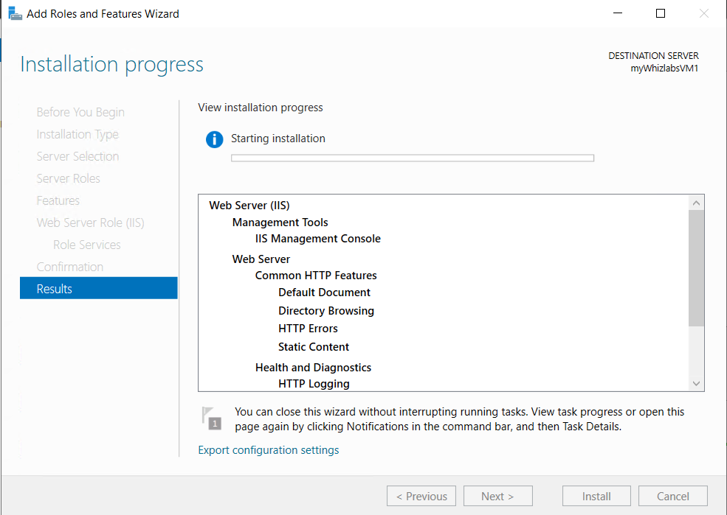

1. Once the installation is complete, click on **close.**
2. Open **Internet Explorer** and enter **http://localhost/** in the search bar to confirm the installation on IIS.

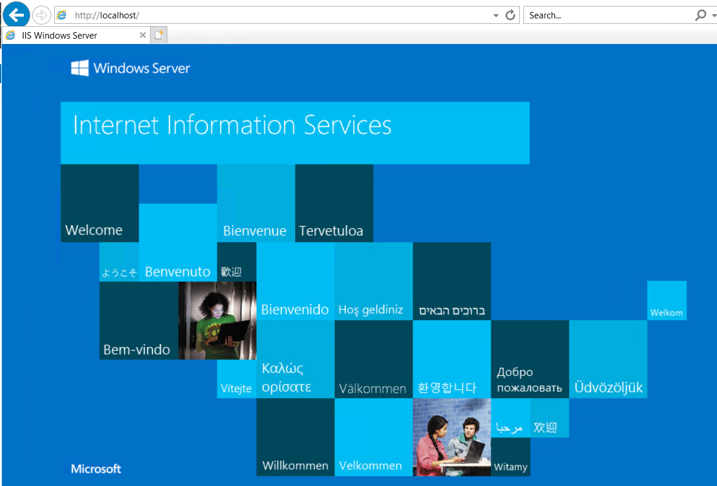

1. Click on the File Explorer.

https://labresources.whizlabs.com/df188e7663ade4ce6b66b8c29f276ae4/25.png

1. Click on **This PC** option in the file explorer window.

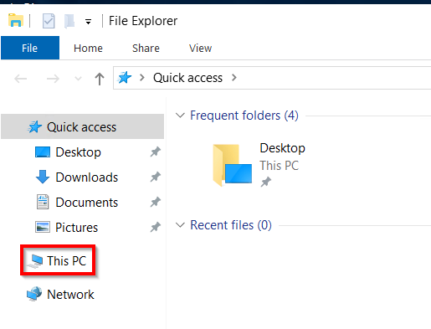

1. Go to **C drive > inetpub > wwwroot** and click on **view** to enable **file name extensions**, then create an **images** folder.

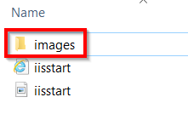

1. In the **images** folder, create a file **Default.html**

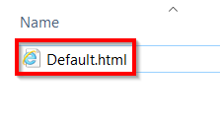

1. Paste the given code in the Doc file and save it.

<h1> This is the Images Server <h1>

1. In the search box at the top of Azure Portal, search for **Virtual Machines** and select **myWhizlabsVM2** from the list and click on **Connect**.

# https://labresources.whizlabs.com/df188e7663ade4ce6b66b8c29f276ae4/29.png

1. Repeat steps 2 - 12 to install **IIS** on **myWhizlabsVM2**.
2. Go to **C drive > inetpub > wwwroot** and click on **view** to enable **file name extensions**, then create a **videos** folder.

# https://labresources.whizlabs.com/df188e7663ade4ce6b66b8c29f276ae4/29a.png

1. In the **videos** folder, create a file **Default.html**

# https://labresources.whizlabs.com/df188e7663ade4ce6b66b8c29f276ae4/29b.png

1. Paste the given code in the Doc file and save it.

<h1> This is the Videos Server <h1>

## ****Task 5: Create an Application Gateway****

1. In the search box at the top of Azure Portal, search for **Application gateway** and select it from the list.

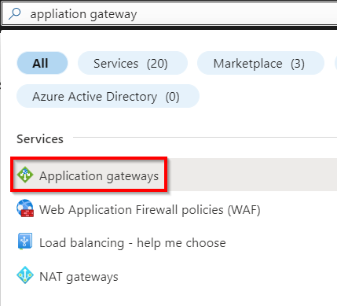

1. On the application gateway page, select **+ Create** and enter or select the following details in the **Basics** tab.

* Resource group : Select **rg_eastus_XXXXX**
* Instance details :  
  + Application Gateway Name : Enter **WhizlabsGateway**
  + Region : Select **East US**
  + Tier: Select **Standard V2**
  + Maximum Instance count:**2**
* Configure Virtual Network
  + Virtual Network: Select **whizNet1**
  + Subnet: Select **myApplicationGatewaySubnet**

**Note - It might take 5-10 min for the vnet to get displayed, try refreshing the page once or twice in 2-3mins.**

# https://labresources.whizlabs.com/df188e7663ade4ce6b66b8c29f276ae4/31.png

# https://labresources.whizlabs.com/df188e7663ade4ce6b66b8c29f276ae4/32.png

1. Click on **Next: Frontends** option and enter or select the following details:

* Frontend IP address type: Select **Public**
* Public IP address: click on **Add new**
  + Name: Enter **WhizlabsGatewayIP**

# https://labresources.whizlabs.com/df188e7663ade4ce6b66b8c29f276ae4/33.png

1. Click on **Next: Backends** optionand click on **add a backend pool**.

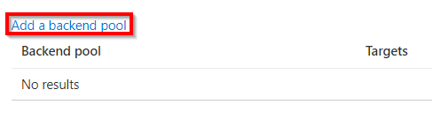

1. On **Add a backend pool** page, enter or select the following details and click on **Add**.

* Name: Enter **imagepool**
* Add backend pool without targets: Select **No**
* Target type: Select **Virtual machine**
* Target: Select **myWhizlabsVM1**

# https://labresources.whizlabs.com/df188e7663ade4ce6b66b8c29f276ae4/35.png

1. Click on **add a backend pool** and enter or select the following details and click on **Add**.

* Name: Enter **videopool**
* Add backend pool without targets: Select **No**
* Target type: Select **Virtual machine**
* Target: Select **myWhizlabsVM2**

# https://labresources.whizlabs.com/df188e7663ade4ce6b66b8c29f276ae4/36.png

1. Click on **Next: Configuration** option and select **+Add a routing rule**.

# https://labresources.whizlabs.com/df188e7663ade4ce6b66b8c29f276ae4/37.png

1. On **Add a routing rule** page, enter or select the following details and click on **Add**.

* Rule name: Enter **RuleA**
* Priority: Enter ***100***
* Listener:  
  + Listener Name: Enter **ListenerA**
  + Frontend IP: Select **Public**
  + Protocol: Select **HTTP**
  + Port: Enter ***80***
  + Click on **Add**
* Backend targets:  
  + Target type: Select **Backend pool**
  + Backend target: Select **imagepool**
  + Backend settings: click on **add new**
    - Backend settings name: Enter **SettingA**
    - Backend protocol: Select **HTTP**
    - Backend port: Enter **80**
    - Click on **Add**

Path-based routing: Click on **Add multiple targets to create a path-based rule**

* Target type: Select **Backend pool**
* Path: Enter **/images/\***
* Target Name: Enter **ImageRule**
* HTTP settings: Select **SettingA**
* Backend target: Select **imagepool**
* Click on **Add**

Path-based routing: Click on **Add multiple targets to create a path-based rule**

* Target type: Select **Backend pool**
* Path: Enter **/videos/\***
* Target Name: Enter **VideoRule**
* HTTP settings: Select **SettingA**
* Backend target: Select **videopool**
* Click on **Add**
* Click on **Add**

# https://labresources.whizlabs.com/df188e7663ade4ce6b66b8c29f276ae4/38.png

# https://labresources.whizlabs.com/df188e7663ade4ce6b66b8c29f276ae4/39.png

1. Click on **Next: Tags**, leave it as default and click on **Next: Review + create** then select **Create**

# https://labresources.whizlabs.com/df188e7663ade4ce6b66b8c29f276ae4/40.png

## ****Task 6: Test the Application Gateway****

1. In the search box at the top of Azure Portal, search for **Application gateway**, select **WhizlabsGateway** from the list and copy its public IP address.

# https://labresources.whizlabs.com/df188e7663ade4ce6b66b8c29f276ae4/41.png

1. Paste the IP in new browser window in the format **public_ip/images/Default.html**

# https://labresources.whizlabs.com/df188e7663ade4ce6b66b8c29f276ae4/42.png

1. Similarly type **public_ip/videos/Default.html** in a new browser window.

# https://labresources.whizlabs.com/df188e7663ade4ce6b66b8c29f276ae4/43.png

### ****Do you know?****

Azure Application Gateway supports SSL offloading, allowing the gateway to handle the SSL/TLS encryption and decryption, reducing the load on backend servers. It also provides URL-based routing and session affinity to ensure traffic is directed to the appropriate backend servers. Additionally, it integrates with Azure Active Directory for authentication and authorization of web traffic.

**Completion and Conclusions**

1. You have successfully logged into Azure Portal.
2. You have successfully created a Virtual Network .
3. You have successfully created Virtual Machines.
4. You have successfully Installed IIS in both Virtual Machines.
5. You have successfully created an Application Gateway.
6. You have successfully tested the Application Gateway.
7. You have successfully tested the validation.
8. You have successfully deleted the resources.